A | B | Ci | Co | S
  S | AB/Ci | 0 | 1
  S | 00 | 0 | 1
  S | 01 | 1 | 0
  S | 11 | 0 | 1
  S | 10 | 1 | 0
  S | $$\overline{A}\overline{B}Ci+\overline{A}B\overline{Ci} + ABCi+ A\overline{B}\overline{Ci}$$  = B( $\overline{A}\overline{Ci}$ + $ACi$) + $\overline{B}$($\overline{A}Ci$ +$A\overline{Ci}$)  = B($\overline{A⊕ Ci})$ + $\overline{B}$($A⊕Ci)$  = B$⊕$($A⊕Ci)$
0 | 0 | 0 | 0 | 0
0 | 0 | 1 | 0 | 1
0 | 1 | 0 | 0 | 1
0 | 1 | 1 | 1 | 0
1 | 0 | 0 | 0 | 1
1 | 0 | 1 | 1 | 0
1 | 1 | 0 | 1 | 0
1 | 1 | 1 | 1 | 1
Co | AB/Ci | 0 | 1
Co | 00 | 0 | 0
Co | 01 | 0 | 1
Co | 11 | 1 | 1
Co | 10 | 0 | 1
Co | BCi + AB + ACi

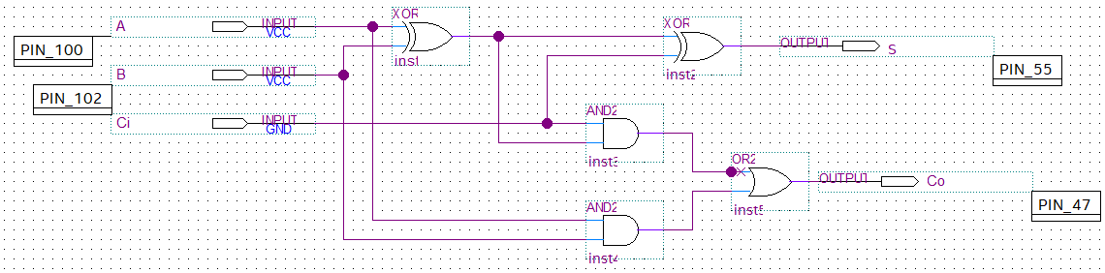
Simulation: This is the result of full adder which is on the truth table above.
